Fairway Ridge Garden Contest
Applications Due by July 1st
Judging will be on the front yard only and will take place the last week of July
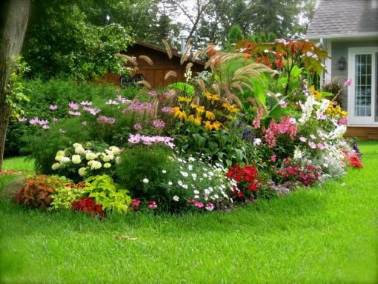

Name:

Address:

Phone:

Email:

Do you give permission for a picture of your home to be put on our website? YES_______ NO_______

